Variable: reference which can store different values

Ex: var bh=23;

Bh=556;

In programming variable is a reference.

Stack data structure stores data types .

Heap store Objects

In java we have 8 data types :

Number character Boolean

Int float char Boolean

short int float

long int double float

byte

**byte=🡺1 byte**

**char🡺1 byte**

**short🡪2 bytes**

**int🡺4bytes**

**long🡺8 bytes**

**float🡪4bytes**

**double float🡪 8 bytes**

**Boolean🡺1 byte**

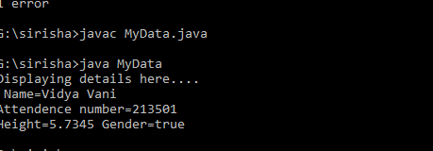

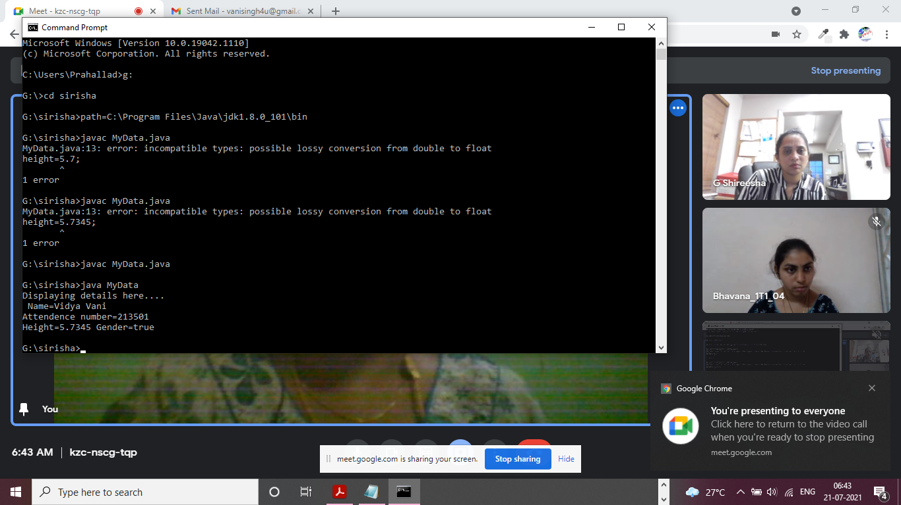

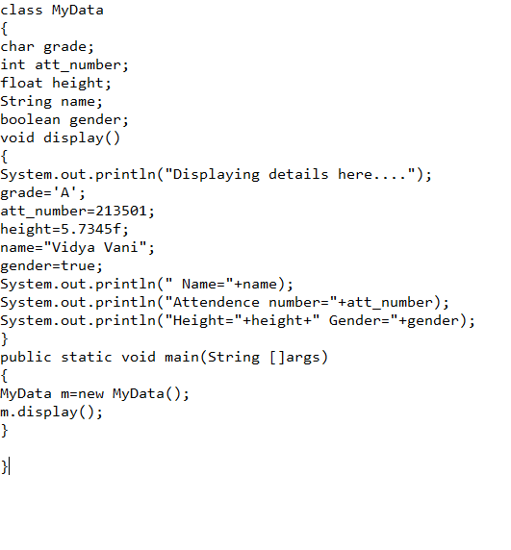

**COnsrtuctor: It supervises the whole class that is if vairbales are not initialized constructor take care and initializes them with default values and also checks whether the class is complete or not.**

**Every class has a default cons..**

**Syntax of cons.. is same as function where function will have return type but construc… return type is class type**

**Instance vairblaes: They blong to the whole class means function, constructor they can use it.**

**Local variables: declaring variables inside the function or a consturcotr**

